Java Full Stack
Technologies:
- Core Java & Java 8
- Spring Core
- Spring Boot
- Junit & Mockito
- SQL
- Microservices
- Angular - Jasmine & Karma
Software’s required
- JDK 21
- Eclipse IDE
- VS Code
- MySQL 8

Java
- It is platform independent
- object oriented
Variables & Datatypes
Variables: These are placeholders to store data
Datatypes: These are used to specify a variable can store what type of data like number, string, date, arrays objects and so on, there are 2 types
- Primitive datatypes - byte(1), short(2), int(4), long(8), float(4), double(8), boolean, char(2)
  - Integer - byte, short, int & long
  - Floating - float, double
- Derived datatypes - arrays, classes, interfaces, String
Datatypes Demo
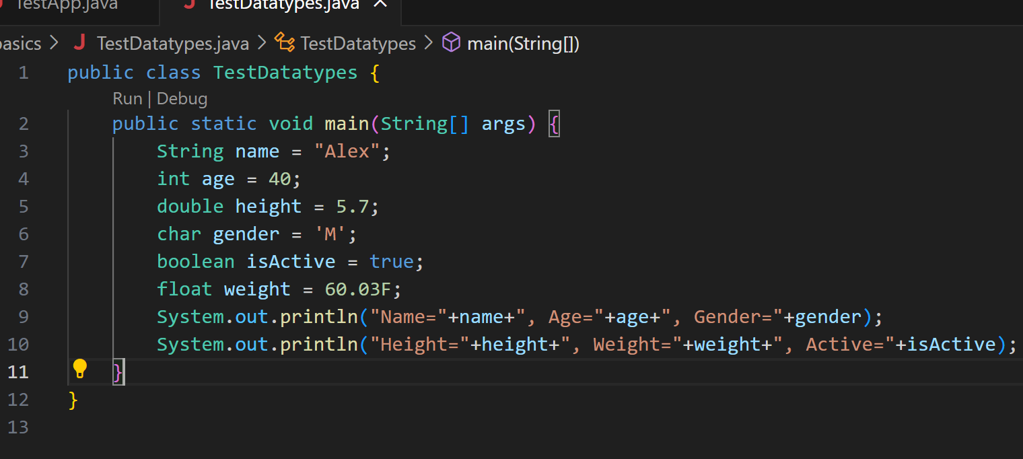
Operators:
+, -, *, /, =, ==, ++, --, <, >, <=, >=, !=, %, &&, ||, ?:, << ,>>, >>>
Operators Demo
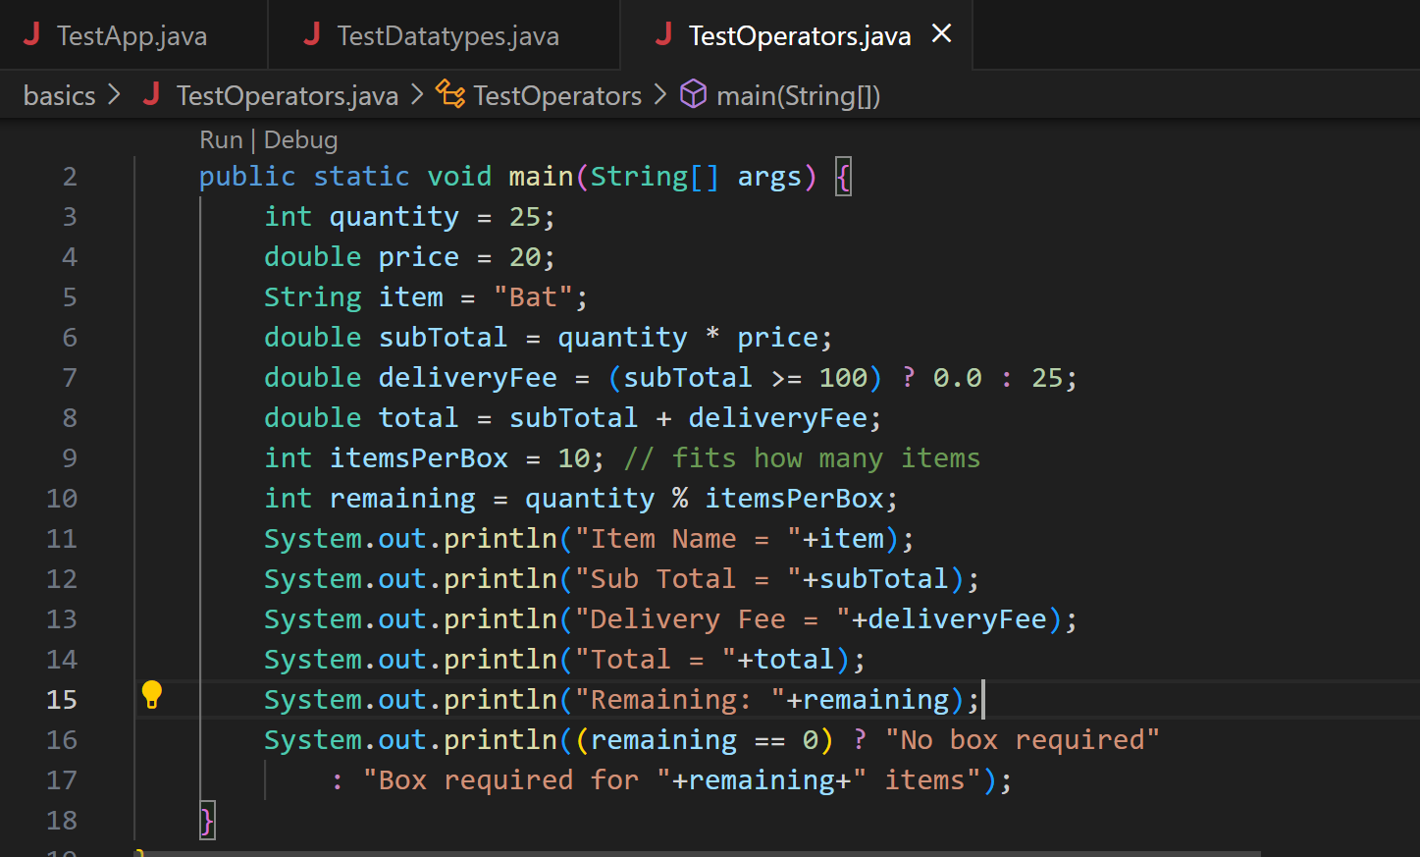
Scanner class: It is used to take input from the keyboard
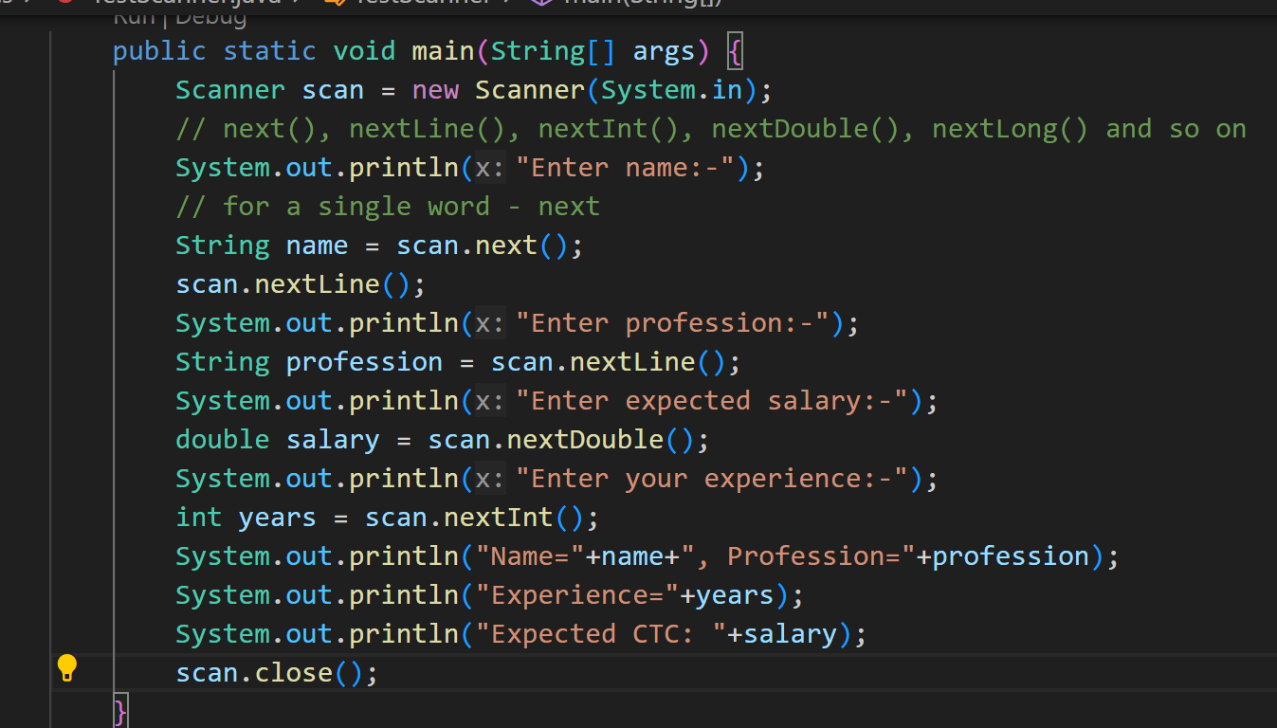
Conditional Statements
- if
- if else
- if else if else if … else
- switch

Loops:
It is used to repeatedly execute the statements until the condition is true
- for loop
- while loop
- do while loop
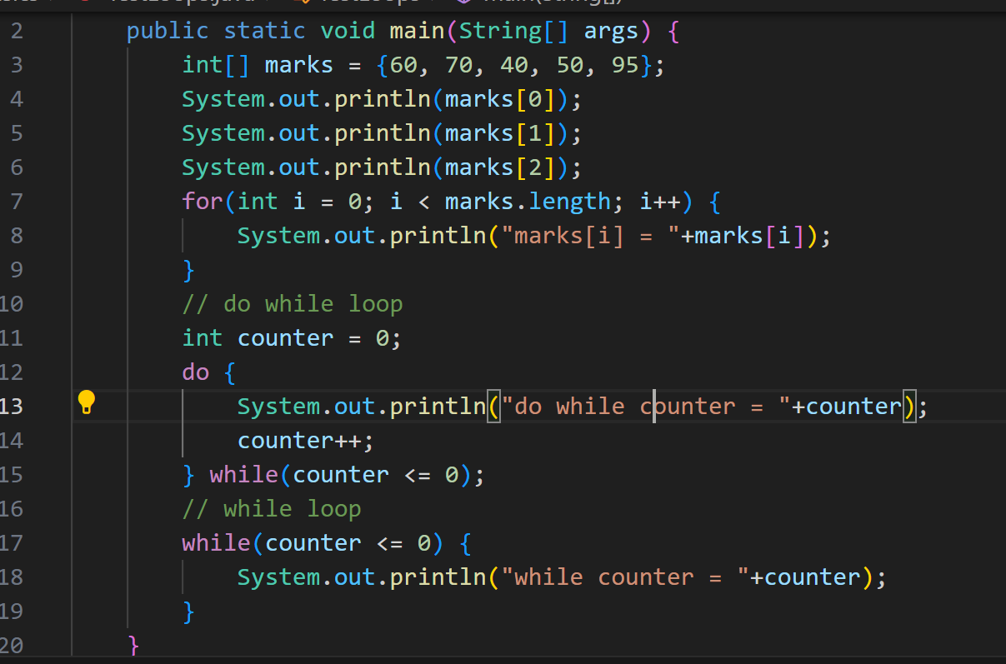

Activity:
- Enter the size of an array and using scanner accept input and store the values in the array using the syntax int[] items = new int[size] , after you store values in the array print min, max and sum of the elements present in the array using single for loop:
Input: Enter the size: 6
-5 10 20 -10 5 30
Output:
Max: 30
Min: -10
Sum: 50
- Enter some elements and store them in an array and copy all the negative numbers in one array & positive numbers in another array and print the elements present in both arrays, if the input element has 0 don’t copy to any array
Input: 10 20 -10 0 -20 30 -30
Output:
-10 -20 -30
10 20 30

